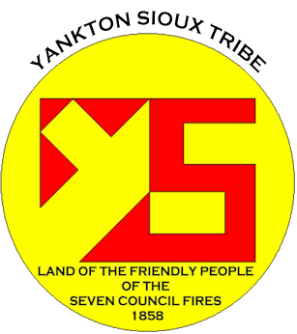 

Issue

*final*

***thoughts...***

*In The Next Issue*

***current topics >>>***

***coming soon >>>***

*Finding An Agent That’s Right For You*

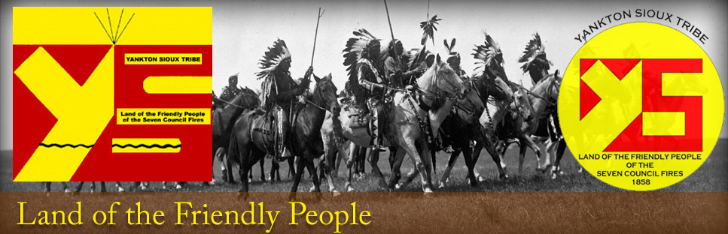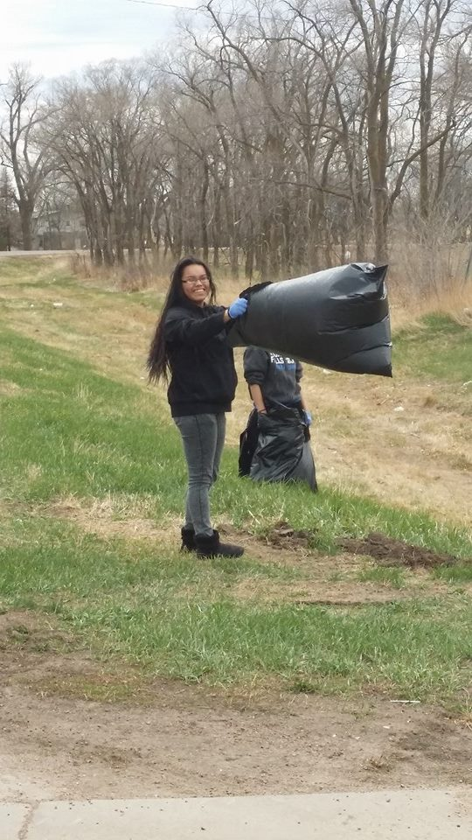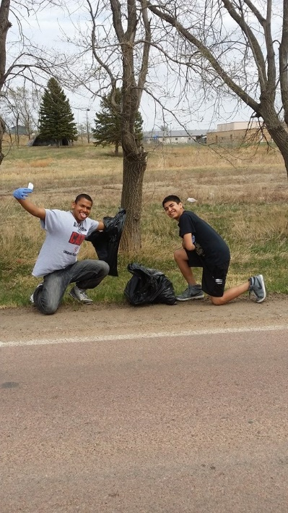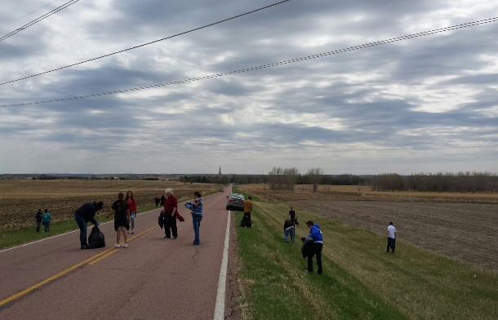

**FOUR**

(Cont. from first page)

The Fort Randall Casino. Alco, Family Dollar, Superfoods and Buches all supported our event by donating water and trash bags.

When it comes to Earth Day, it is more about personal responsibility to our reservation, local community, and planet. The term “Think Globally and Act Locally” has never been more important. With global warming and other critical environmental issues at hand, we can all make a difference by taking care of our planet and protecting our natural

**Environmental concerns became front and center in 1970. The founder for Earth Day was Gaylord Nelson a U.S. Senator from Wisconsin. He had witnessed an oil spill in 1969 and it forced him to acknowledge the impact pollution has on our environment. On April 22nd, 1970, 20 million Americans rallied for a healthy, sustainable environment. As a result, the Environmental Protection Agency was created and the Clean Air, Clean Water, and Endangered Species Acts were passed. April 22nd marks the Anniversary for Earth Day and the fight for a cleaner environment.**

***Earth Day History***

*128 (a) Tribal Response Program/Brownfields and the Former Guest House.*

***Composting! Coming soon!!!***

*In this newsletter we will be informing the reader on the history of Earth Day and how it has exploded into global realization. As everyone is aware, environmental issues are gaining popularity and momentum in today’s world. Issues of global climate change, pollution, waste control, and reusable energy are now so important and there are hundreds of organization’s trying to find solutions to help clean up the planet. Earth Day serves as a stepping stone to help our planet.*

The response received from every Tribal entity was a positive step in the right direction.

The Yankton Sioux Housing Authority was the first to reach out and offer participation for April 22nd. They donated trash bags, rakes, gloves and donuts for the morning participants, not to mention, for all tenants that participated they would receive $10 an hour off from their back rent!!

The Yankton Sioux Tribe Environmental Protection Program, along with the 128 (a) Tribal Response Program/Brownfields sent out a reservation wide memo to all Tribal entities in an attempt to inform them of the upcoming Earth Day event. Letters were sent to: YST, I.H.S., YSHA, Marty Indian School and the Fort Randall Casino,

***Earth Day 2014!***

***Marty Indian School Students doing their part for Earth Day.***

***Armantha having fun on Earth Day!***

**YST EPP/GAP**

**Mr. Richard Leasure, EPP/GAP Director**

**128(a) Tribal Response Program/Brownfields**

**Ms. Danielle Zephier, Brownfields Coordinator**

**YST Utilities Program/Solid Waste**

**Mr. Bryan Heth, Utilities Manager**

**Mr. Sheldon Powers, Solid Waste Disposal Technician**

**Phone: (605) 384-5003**

**Fax: (605) 384-5006**

**Visit us @ www.yst-epo.org**

PO Box 1153

Wagner, SD 57380

Environmental Protection Program

natural resources for future generations to come.

The Marty Indian School students should all be commended for taking that lead role in understanding the importance of protecting our environment and making it one of their missions as today’s generation of environmentalist’s.

Contact us at **(605) 384-5003** www.yst-epo.org

**Earth Day – Marty Indian School Students**

***“The response received from every Tribal entity was a positive step in the right direction.”***

The Marty Indian School Student Council took an initiative in cleaning up the environment from the beginning of the school year. They started Recycling with the YST Recycling Program and also took an active role in making sure the M.I.S. High School students were participating in this event. YST EPP and Brownfields donated trash bags, gloves, water and refreshments to the school. (Cont. on last page)

The Yankton Sioux Tribe recruited staff from all tribal programs to come out and help with the clean-up. The Tribal Health Program donated 7 cases of water to the participants to keep them well hydrated. The Indian Health Service was also instrumental in providing gloves to the Earth Day participants.

*Earth Day 2014*

*History of Earth Day*

*128(a) Tribal Response Program/Brownfields*

*YST Utilities/Solid Waste*

*YST Recycling*

*YST Roads*

***“The fight for a clean environment continues in a climate of increasing urgency, as the ravages of climate change become more manifest every day. We invite you to be a part of Earth Day and help write many more victories and successes into our history.”***

**A Quarterly Insight into the Environmental Protection Program**

*“Protecting Human Health and the Environment”*

***Volume 1 >>>***

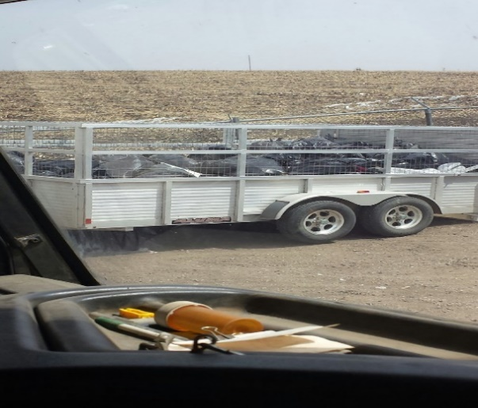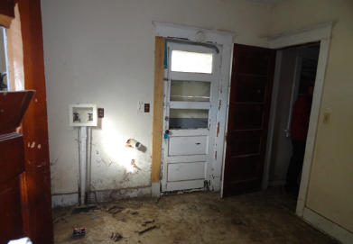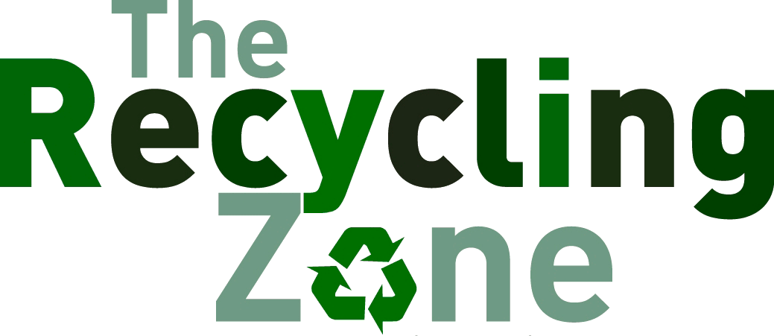

*Brownfields Program/*

*128(a)Tribal Response*

***From the Roads Desk >>>***

*The Recycling Program accepts: Paper, Newspaper, Cardboard, Plastics, Aluminum Cans and Tin Cans.*  ***Anyone can recycle with us!***

**The Yankton Sioux Tribe Utilities Program requests that your garbage cans be set curbside in order for your trash to be disposed of properly. Our Solid Waste Disposal Technician has a regular scheduled route. Inclement weather may hinder that schedule, otherwise** **please set your garbage cans curbside in a timely manner.** Thank you!

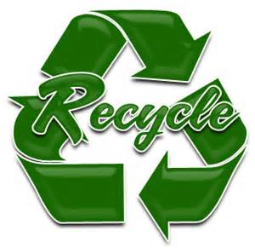

*What items does the Recycling Program*

*Accept?*

*Q:*

*A:*

***ask the Recycling Program>>>***

**Why Recycling Is Important**

* **Recycling reduces waste products in landfills**
* **Recycling saves energy**
* **Recycling helps mitigate global warming and reduce pollution**
* **Recycling helps you save money**

*The recycling trailers were hard at work hauling trash for Earth Day! A big THANK YOU to the folks in the Roads Dept., YSHA and Solid Waste for taking the time to pick up all the bags filled from Earth Day!*

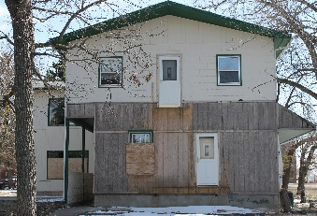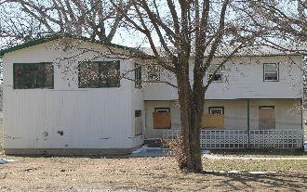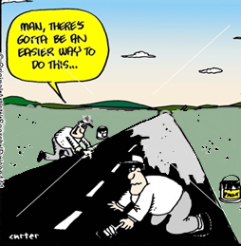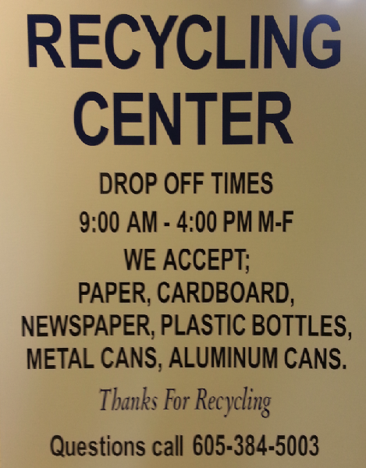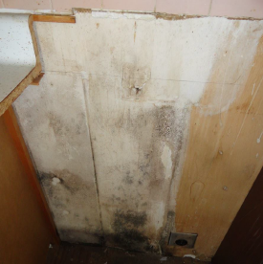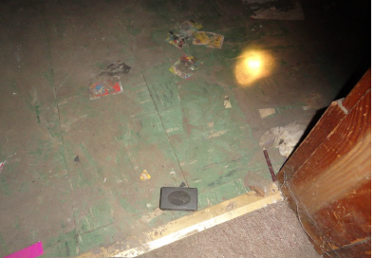

***From the YST Utilities Desk...***

**YST Utilities Program:**

**Mr. Bryan Heth**

**Utilities Manager**

**Phone: (605) 384-5003**

**Fax: (605) 384-5006**

*For More Information About Recycling or Garbage Disposal, Contact:*

*On December 31, 2013, a Phase I and Phase II Assessment was completed on the Former Guest House located on the Marty Indian School campus. The EPA contractor tasked Weston Solutions, Inc.to assess the site. They conducted a Targeted-Brownfields Assessment (TBA) including a hazardous material assessment for Asbestos Containing*

*hazardous materials that could be released when the debris is disturbed. Potential for Asbestos Containing Materials and Lead Based Paint exist and are being released into the surrounding environment. The overall goal of the Yankton Sioux Tribe Brownfields effort is to ensure that contamination does not threaten public health and the environment during and after redevelopment of the site. The objective of this project is to clean up the Former Guest House in order to protect public health and the environment for planned future use. The cleanup and/or abatement will be advertised in the papers. The project completion date will be September 15th, 2014.*

**Any questions or concerns please call: Danielle Zephier, Brownfields Coordinator at (605) 384-5003**

*Former Guest House*

*Materials (ACB), Lead Based Paint (LBP), and other hazardous materials. This building is situated on the Marty Indian School campus and is easily accessible to students. The complex was boarded up due to illegal activity. A cleanup on this site will require an asbestos abatement contractor to remove the debris under appropriate controls to limit the exposure of anyone in the area to asbestos or*

***YST Recycling Trailers***

***Projects that will be included in the YST Transportation Improvement Program (TIP)***

**Long Range Transportation Plan (LRTP)**

* Highway 46 to Greenwood Road – BIA Route 29 and BIA Route 30
* Pave 386th Avenue (Rucker’s Road)
* Pave road from Marty East to highway going south of Wagner
* Wagner Elderly Project – Red Bird Housing, pave and repair road
* Greenwood Cultural Center Parking Lot
* Marty Main Street – BIA Route 34
* Lake Andes South Housing Project
* White Tallow Project –Marty North Access Road)
* Marty Streets – BIA Route 1400
* Wagner South Housing – BIA Route 1100
* Multi-Township Gravel Project
* Buffalo Underpass Project – BIA Route 30
* Reservation-wide Striping Project
* Community Walk-way Projects – Tribal Housings and Tribal School Walkways

*The Roads/Planning Department will be starting their projects this summer for the Yankton Sioux tribe. (Transportation Improvement Plan – TIP)*

**The Solid Waste Department will be removing trash cans from the tenant’s residents. There are many outstanding tenant bills that must be paid. If you have an outstanding debt please contact the Utilities Program so that we can settle your debt and continue your garbage service. Thank you!**

*Mold on kitchen wall.*

*Laundry room-LBP and mold on walls.*

*9 x 9 Tile-Asbestos Containing Materials (ACM)*

Option congue nihil imperdiet doming quod

***>>>***

Option congue nihil imperdiet do

ming id quod mazim placerat facer minim veni am ut wisi enim ad min

imeniam, quis erat nostr uexerci tation ullamcorper nostru exerci tation ullam corper et iusto odio dig nissim qui blandit praesent lupta. Tummer delenit augue duis dolore te feugait nulla facilisi. Con erattis sectetuer adip iscing elit, sed erat diam nonummy nibh magna erat aliquam erat volutpat. Nam liber tummy nibh ut wisi enim ad minim veni am, quis nostruexerci tation.

*From the YST Roads Department!*